Project Title: Exhaustive Analysis of Indian Agriculture Sector Using Power BI

* Step by Step Process For:
* Data Loading
* Data Transforming

Step 1:

Open Power BI and click on the blank Report

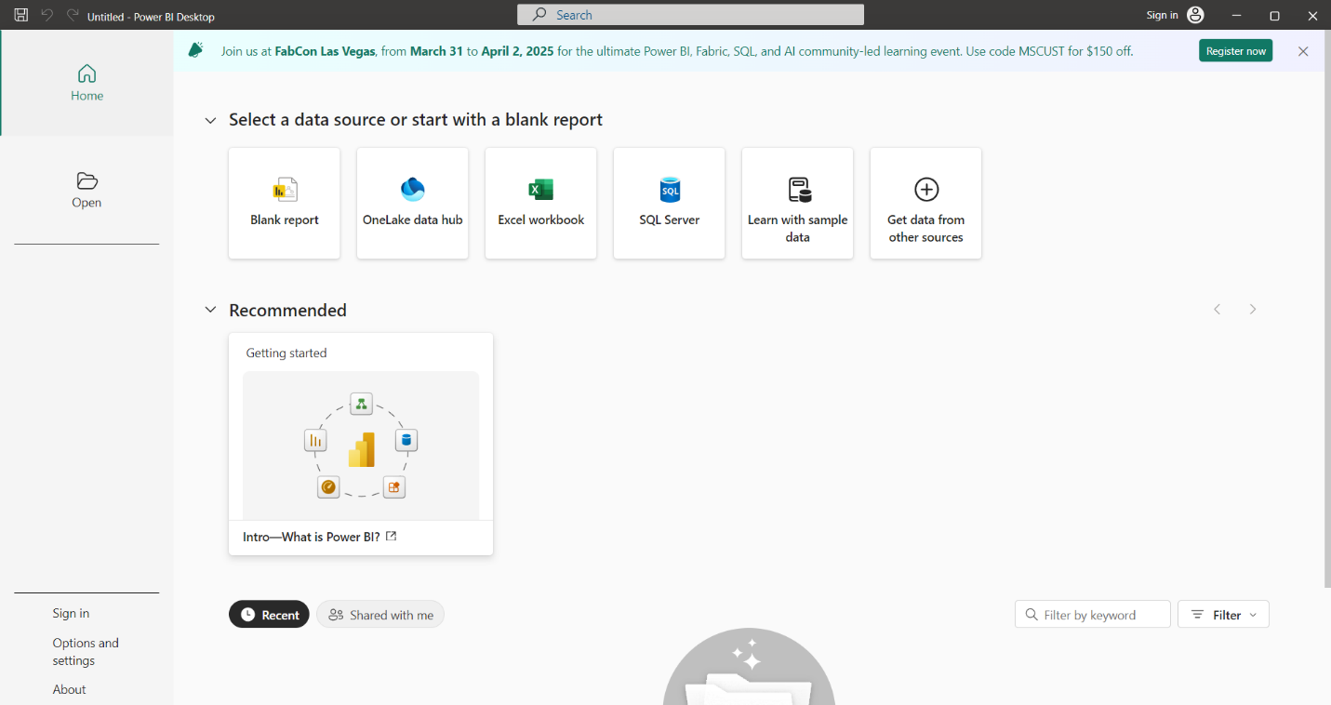

Now You can you can find more options on the canva Board

Step 2:

Click on the Get Data Option

Now You can Find More options For Loading the data

Choose Accordingly What the type of file you have

Example : I have a (.csv) File

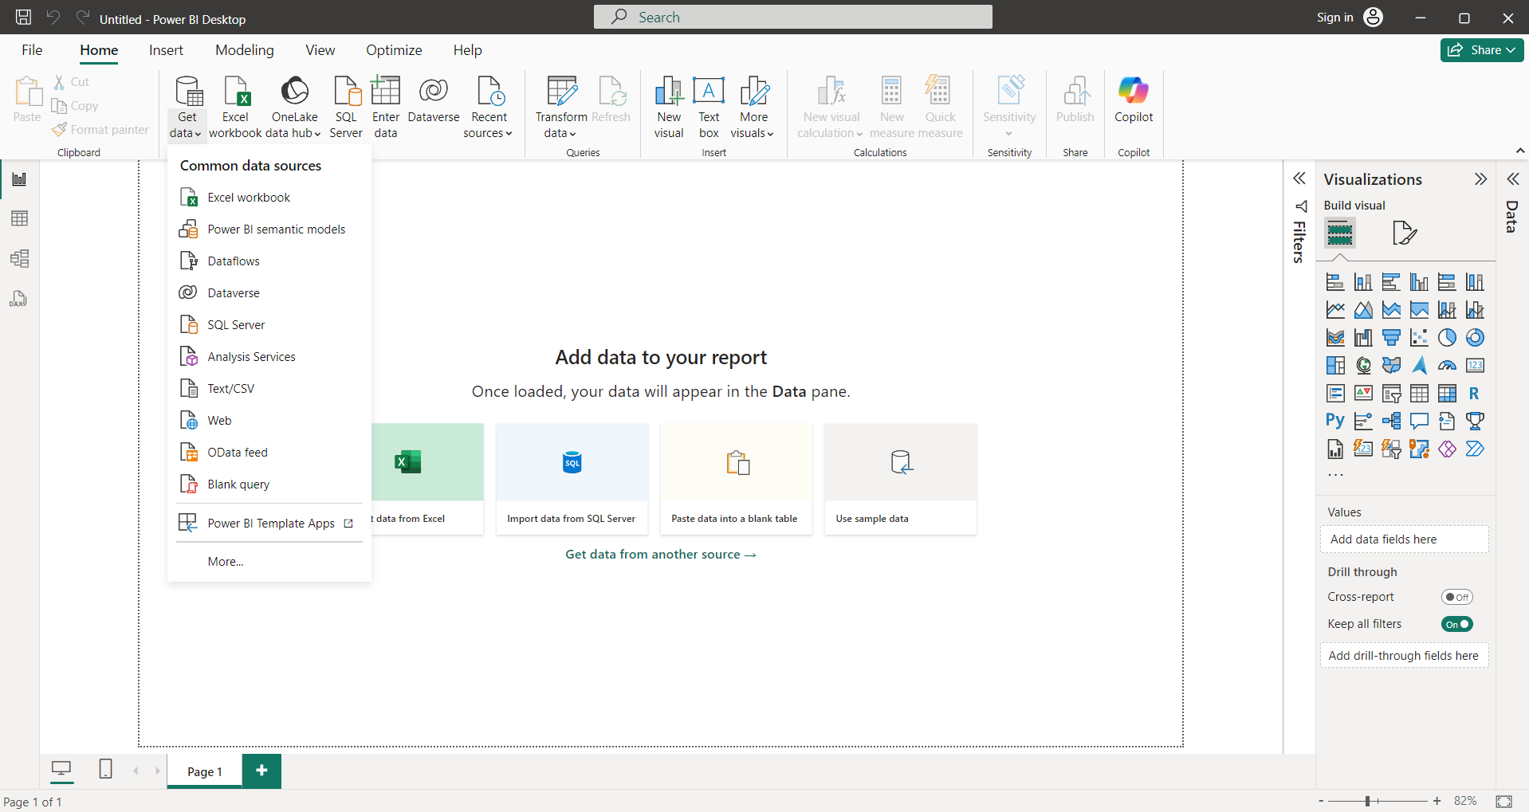

Click on the Text/csv Option and Choose Your File

After Uploading the data File You can See The File Like This

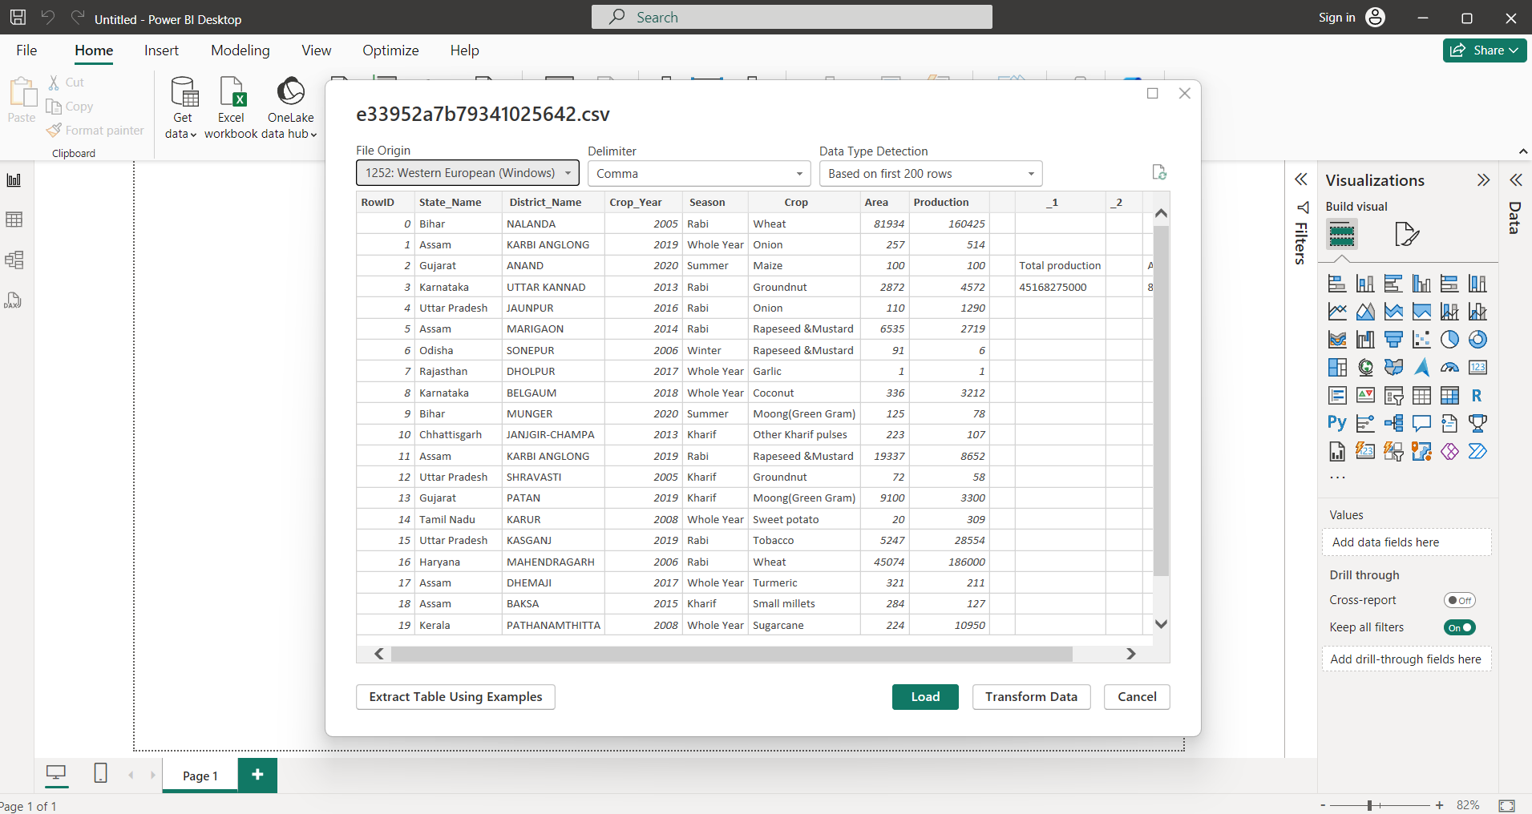

Step 3:

Now There are Two Options Below The Data Table

1. Load 2. Transform Data

If Your Data is Totally Clean and There is No Errors in the data Then click on on the Load Button or else Click The Transform Data Options and clean the data

Now I am click the Load option

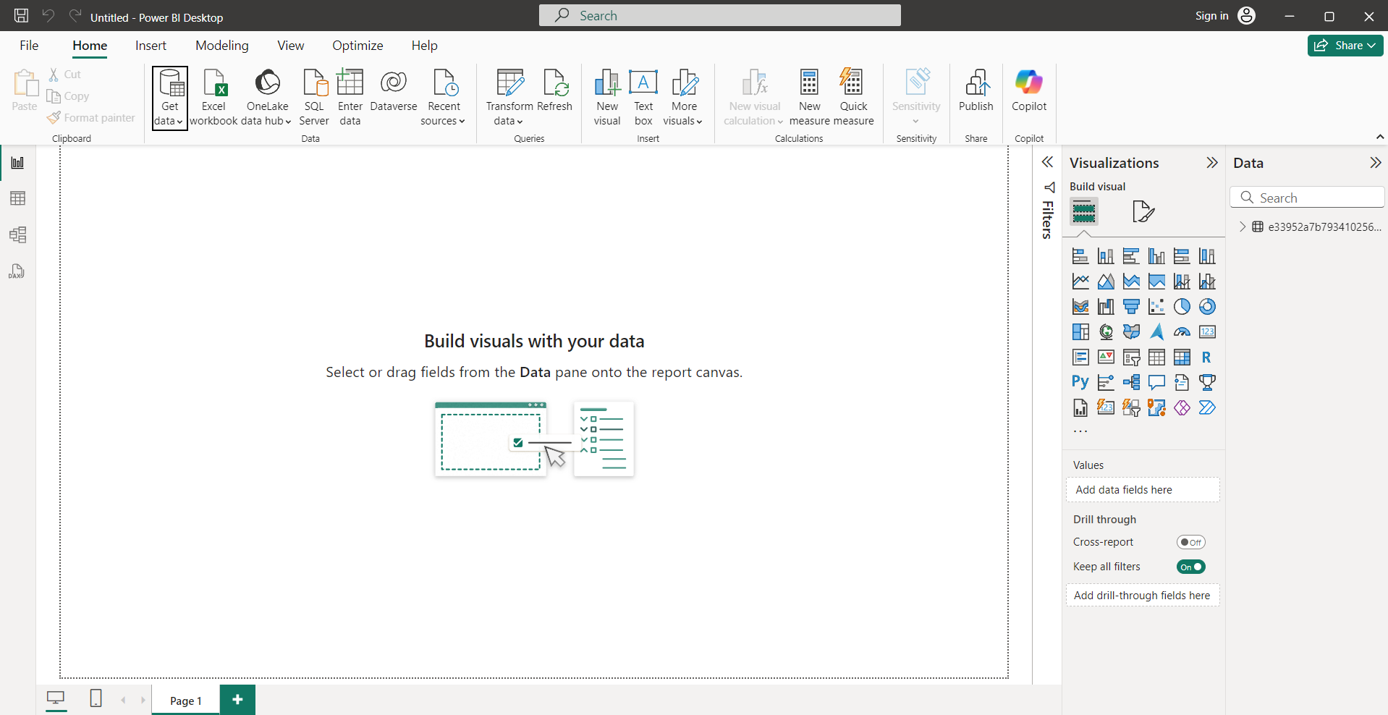

After Load The data you can find it in RHS Edge

Also You can Find 3 View Options in LHS:

1. Report View (visualize The Data in Graphs and Charts Format)
2. Table View (Show the Date in the Tabler Format)
3. Model View (You can Merge two or three files in to a single file )

Step 4:

Now Click On Transform Data and it show again Transform data option click on it

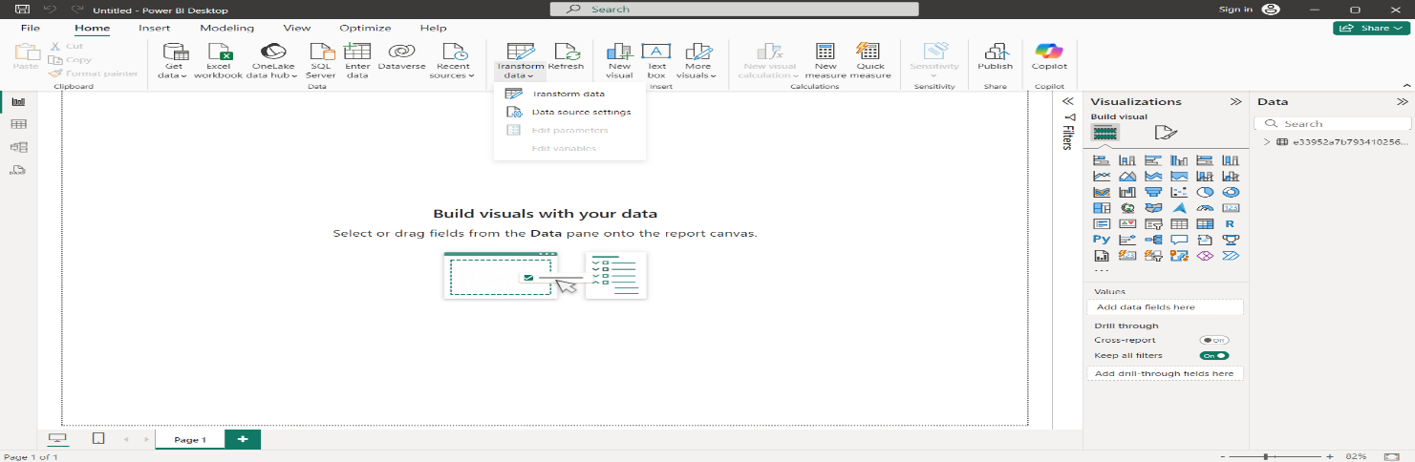

Now it will open in new Tab and you can perform cleaning operations

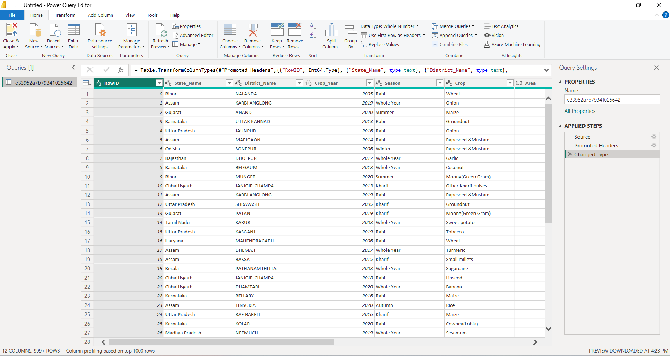

I can find some unwanted data and useless data In my data set so I want to remove that data…… let me show you

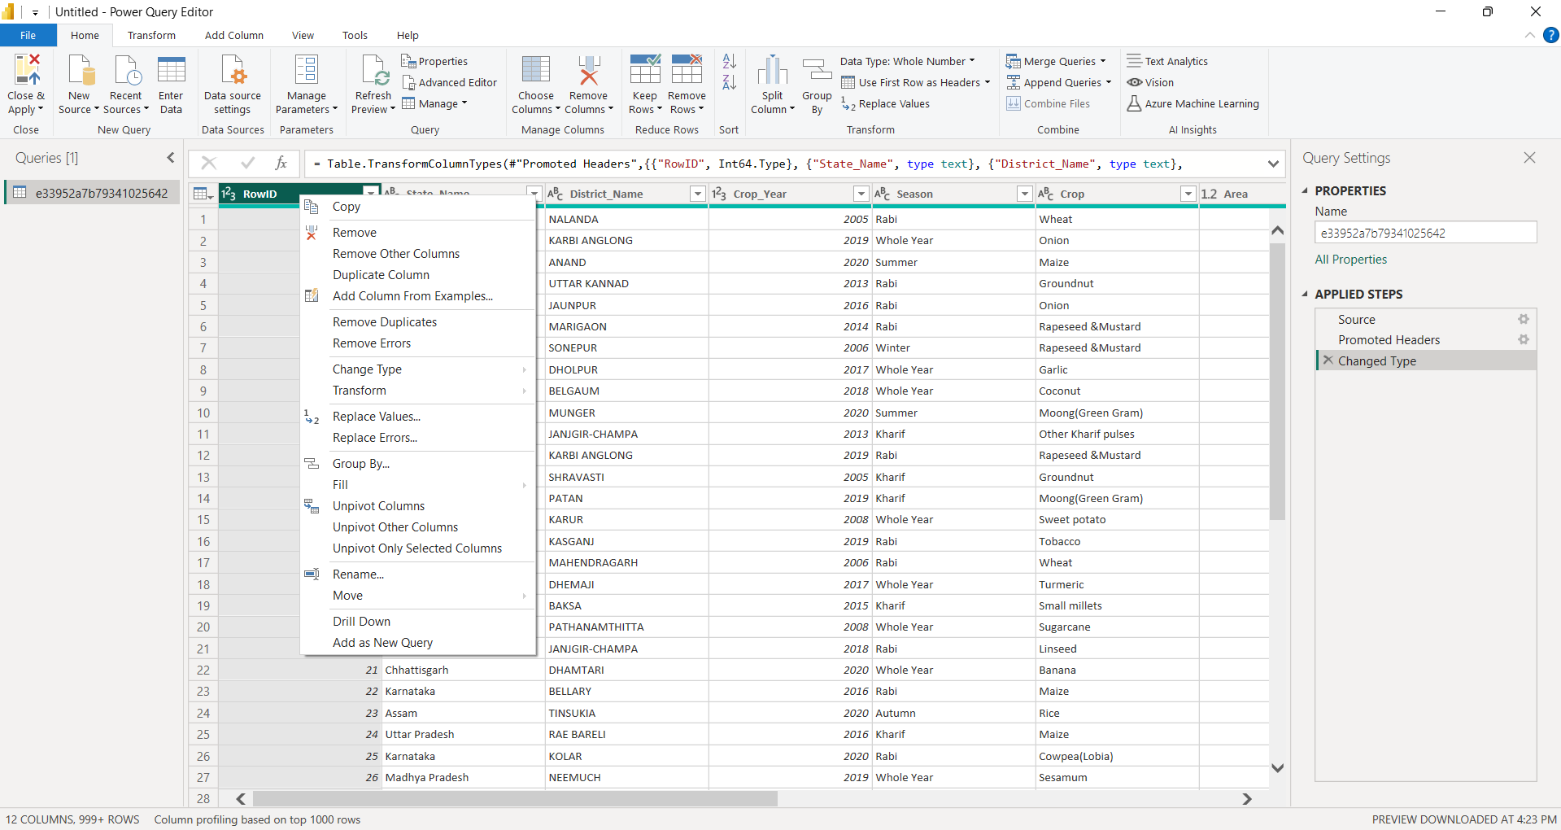

Right Click on the Column What ever you want remove and you can find the option called Remove and click on it and it will Removed from the Data Set

What ever Steps you are Performed in the data it will shows you in the RHS Corner

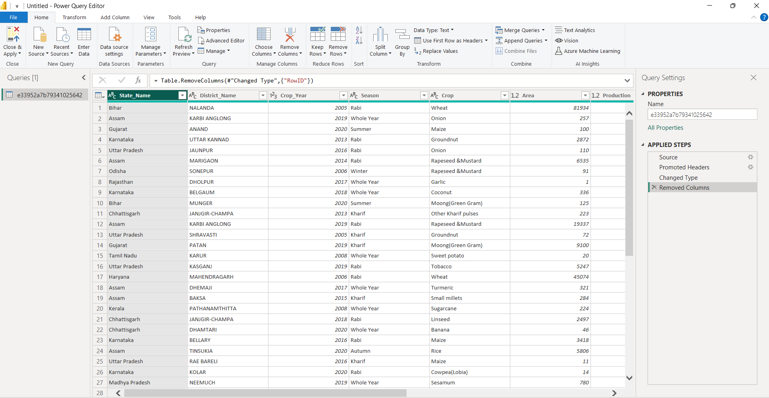

If you Un Expectedly Removed That Column Then just Click on The Wrong Mark(X)

It will comeback in there position

Step 5:

**Check The NULL Values in the data set:**

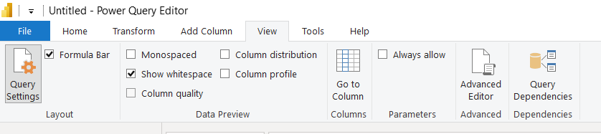

Click The View Button And Click on Column Quality Option

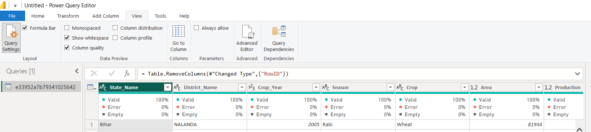

Now You Can See The Options Called Valid, Error, Empty in Each Row And it will Validate the Null values and errors in the data

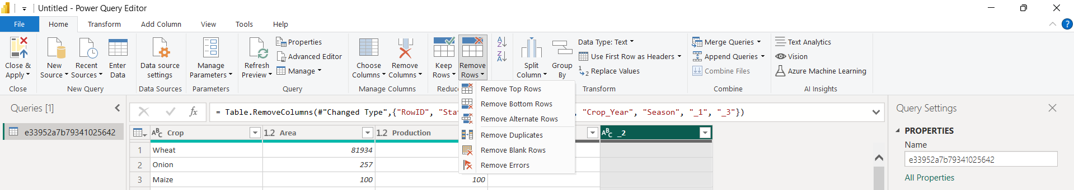

If You Find Any Null Values in the Data Set Just Click On the Remove Rows Option And You can Find 3 Options

1. Remove Duplicates
2. Remove Blank Rows
3. Remove Errors

After all Operations Just Click on the Close and Apply Option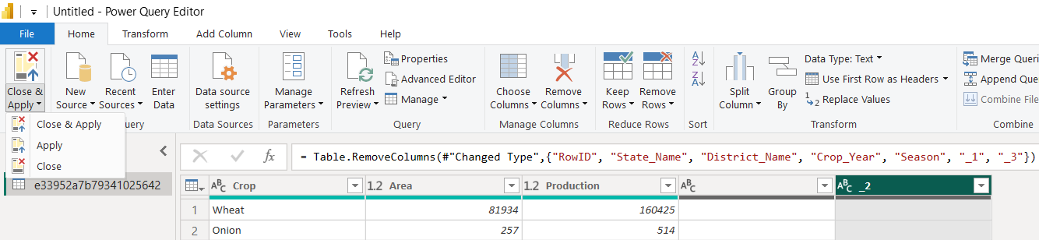

This is all about step by step process for data loading and cleaning……